**Name: AQSA ILYAS**

**Roll No: BIT-24S-009**

**GitHub link:** https://github.com/ilyasaqsa/Python-lab

**LAB: 01**

**Task 1:**

Make 2-2 programs of each datatype.

* **NUMERIC TYPES:**
* **Integer:**

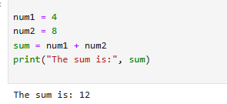

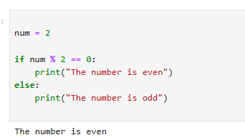

* **Float:**

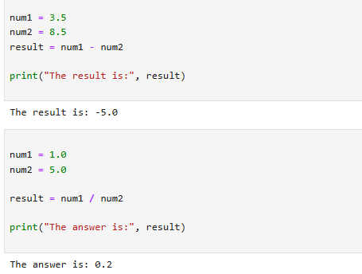

* **Complex:**

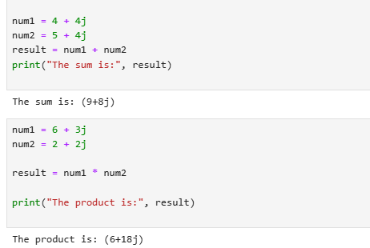

* **SEQUENCE TYPES:**
* **String**

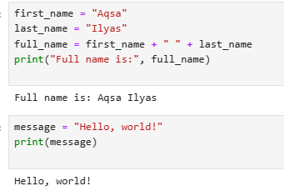

* **List:**

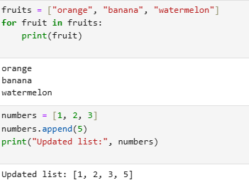

* **Tuple:**

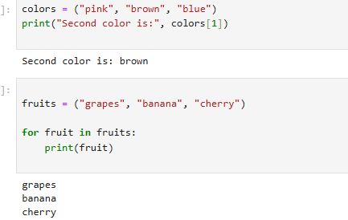

* **Range:**

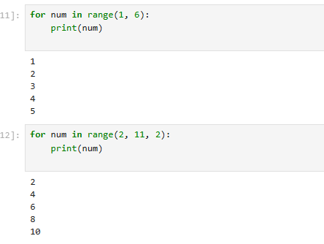

* **SET TYPES:**
* **Set:**

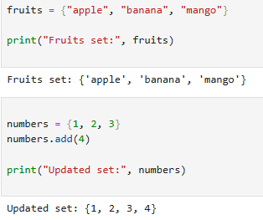

* **Frozen set:**

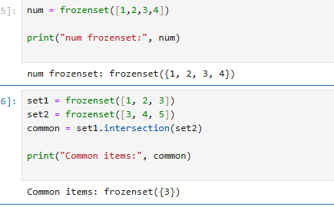

* **MAPPING TYPE:**
* **Dictionary dict:**

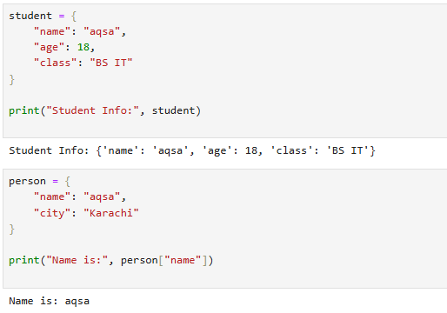

* **BOLEAN TYPE:**

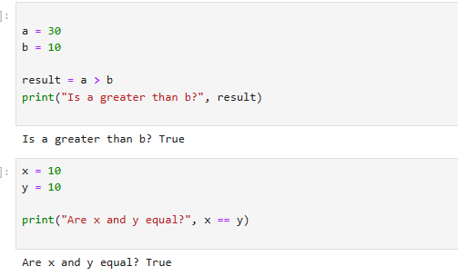

**Task 2:**

**Make up to 5 shapes programs using \***

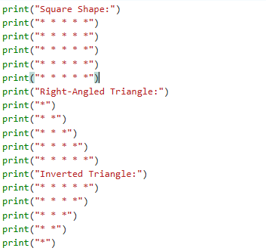

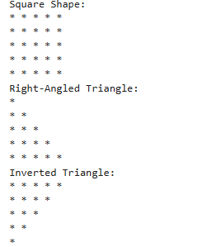

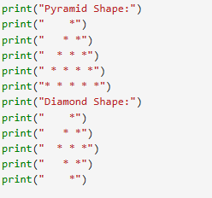

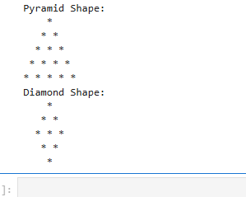

**Task 3:**

Make same shapes you have made in task 2, using * multiple by number.

**Program:**

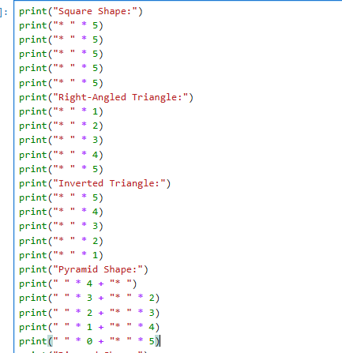

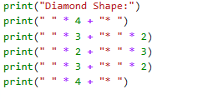

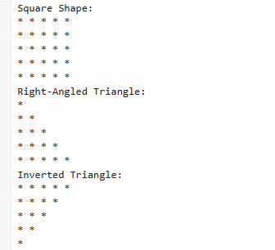

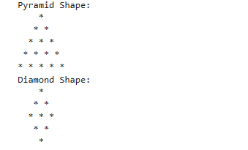

**Lab 2:**

**Task 1:**

Print numbers from 1 to 10 using a for loop.

**Program:**

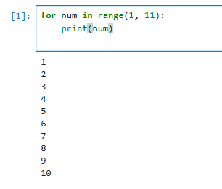

**Task 2:**

Print all even numbers between 1 and 20 using a while loop.

**Program:**

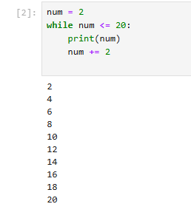

**Task 3:**

Calculate the sum of numbers from 1 to 100 using a loop.

**Program:**

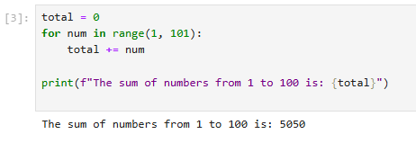

**Task 4:**

Print the multiplication table of 5 using a loop:

**Program:**

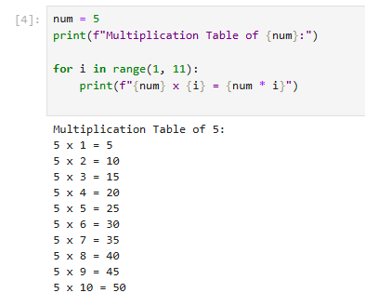

**Task 5:**

Find the factorial of a given number using a for loop.

**Program:**

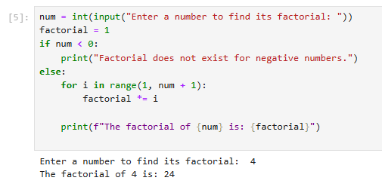

**Task 6:**

Create a list of numbers and print only the odd numbers using a loop.

**Program:**

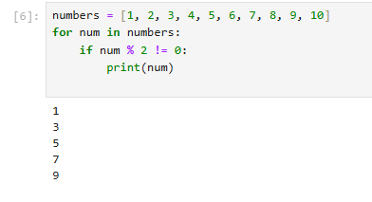

**Task 7:**

Iterate over a list of fruits and print each item.

**Program:**

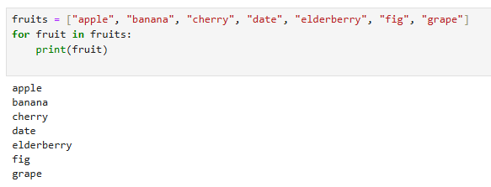

**LAB 4:**

**TASK 01**

Write a python program to take 2 numbers as input and perform all arithmetic operations on them.

**Program:**

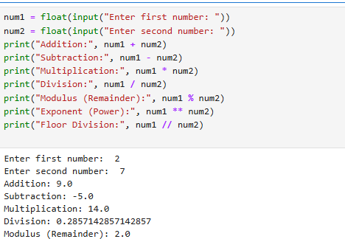

**TASK 02**

Create a function that takes two numbers and return their sum, difference, product, and quotient.

**Program:**

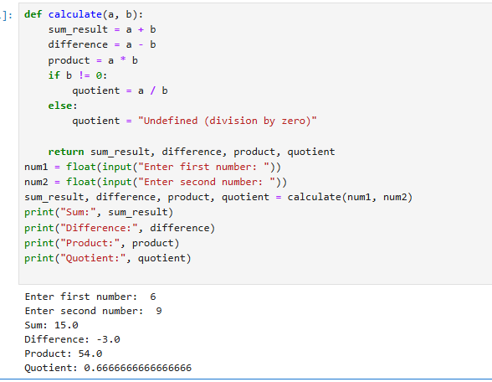

**TASK 03**

Write a python script to find the remainder when one number is divided by another.

**Program:**

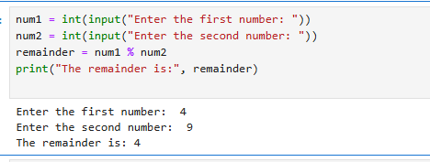

**TASK 04**

Write a program to calculate the area of a circle using the formula: area=pi*r^2.

**Program:**

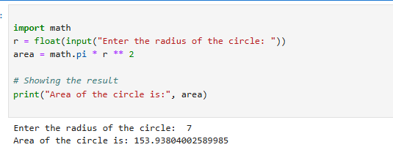

**Task 05:**

Implement a program that takes a number as input and returns its square and cube using exponentiation.

**Program:**

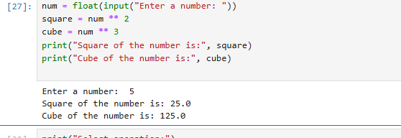

**TASK 06:**

Create a simple calculator in python that allows the user to choose an operation(addition, subtraction, etc.)and inputs two numbers.

**Program:**

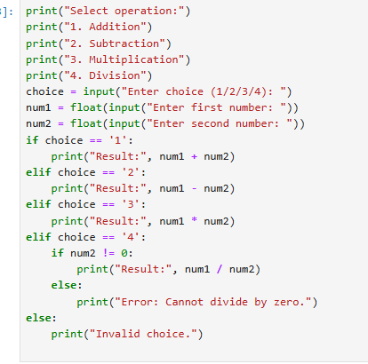

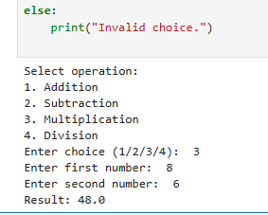

**Lab 5:**

**Task 1:**

Basic Task: Write a program that checks if a given number is positive, negative, or zero.

**Program:**

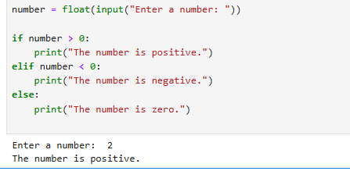

**Task 2:**

Intermediate Task: Write a program that takes user input and determines whether it's a even or odd.

**Program:**

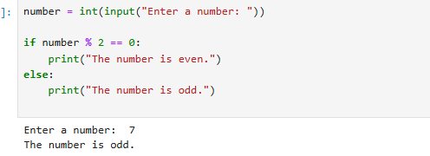

**Task 3:**

Advanced Task: Create a program that asks user to print:

"Excellent" if marks are above 80

"Good" if marks are between 60 and 80

"Needs Improvement" if marks are below 60

**Program:**

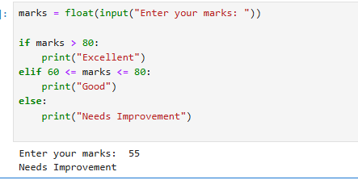

**Lab 6:**

**Task 1:**

Basic Task: Write a for loop to print the first 10 natural numbers.

**Program:**

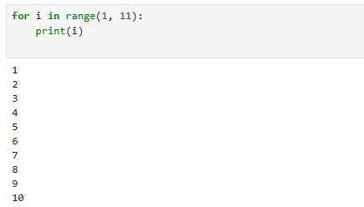

**Task 2:**

Intermediate Task: Write a while loop that prints numbers from 10 down to 1

**Program:**

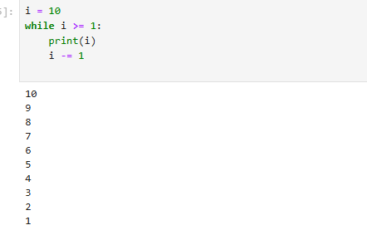

**Task 3:**

Advanced Task: Create a program that uses a for loop to iterate over a string and count the number of vowels.

**Program:**

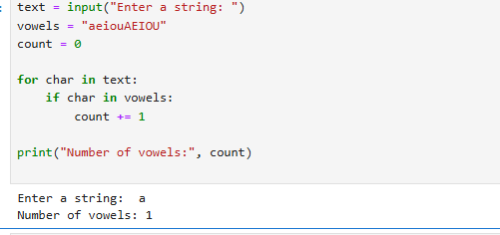

**Challenge Task:**

Write a program that prints the Fibonacci series up to n terms using a while loop.

**Program:**

